Wesley Johnson

Dr. Vinay

Revature Online Certification Program – I

9/29/20

SQL Tutorial Questions and Answers

Website: <https://sqlzoo.net/>

1. SELECT basics

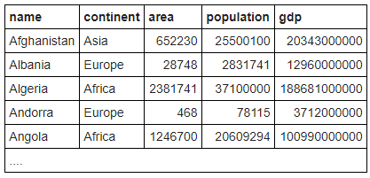

1. Question: The example uses a WHERE clause to show the population of 'France'. Note that strings (pieces of text that are data) should be in 'single quotes'.
2. Answer: SELECT population FROM world WHERE name = 'Germany';

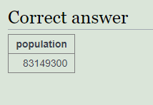

1. Question: Checking a list The word **IN** allows us to check if an item is in a list. The example shows the name and population for the countries 'Brazil', 'Russia', 'India' and 'China'.

**Show the name and the population for 'Sweden', 'Norway' and 'Denmark'**

1. Answer: SELECT name, population FROM world WHERE name IN ('Sweden', 'Norway', 'Denmark');

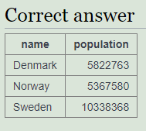

1. Question: Which countries are not too small and not too big? BETWEEN allows range checking (range specified is inclusive of boundary values). The example below shows countries with an area of 250,000-300,000 sq. km. Modify it to show the country and the area for countries with an area between 200,000 and 250,000.
2. Answer: SELECT name, area FROM world WHERE area BETWEEN 200000 AND 250000;

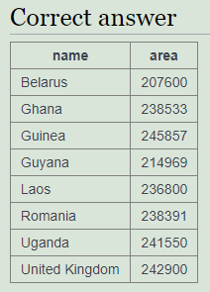

1. SELECT name

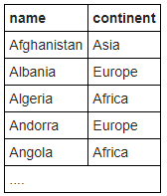

1. Question: You can use WHERE name LIKE 'B%' to find the countries that start with "B".

* The % is a *wild-card* it can match any characters

**Find the country that start with Y**

1. Answer: SELECT name FROM world WHERE name LIKE 'Y%';

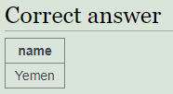

1. Question: **Find the countries that end with y**
2. Answer: SELECT name FROM world WHERE name LIKE '%y';

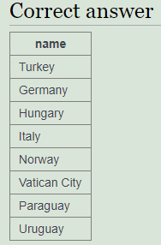

1. Question: Luxembourg has an **x** - so does one other country. List them both.

**Find the countries that contain the letter x**

1. Answer: SELECT name FROM world WHERE name LIKE '%x%';

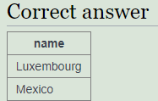

1. Question: Iceland, Switzerland end with **land** - but are there others?

**Find the countries that end with land**

1. Answer: SELECT name FROM world WHERE name LIKE '%land';

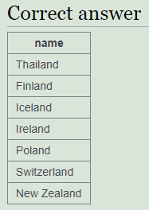

1. Question: Columbia starts with a **C** and ends with **ia** - there are two more like this.

**Find the countries that start with C and end with ia**

1. Answer: SELECT name FROM world WHERE name LIKE 'C%ia';

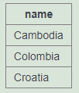

1. Question: Greece has a double **e** - who has a double **o**?

**Find the country that has oo in the name**

1. Answer: SELECT name FROM world WHERE name LIKE '%oo%';

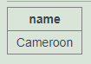

1. Question: Bahamas has three **a** - who else?

**Find the countries that have three or more a in the name**

1. Answer: SELECT name FROM world WHERE name LIKE '%a%a%a%';

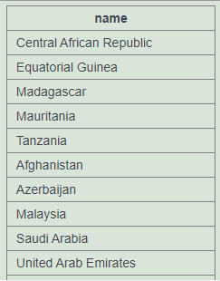

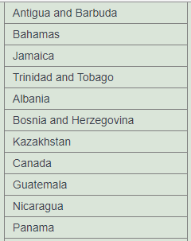

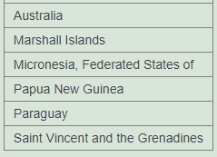

1. Question: India and Angola have an **n** as the second character. You can use the underscore as a single character wildcard.

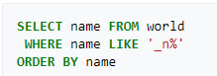

**Find the countries that have "t" as the second character.**

1. Answer: SELECT name FROM world WHERE name LIKE '_t%'

ORDER BY name;

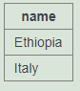

1. Question: Les**o**th**o** and M**o**ld**o**va both have two o characters separated by two other characters.

**Find the countries that have two "o" characters separated by two others.**

1. Answer: SELECT name FROM world WHERE name LIKE '%o__o%';

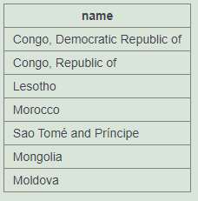

1. Question: Cuba and Togo have four characters names.

**Find the countries that have exactly four characters**

1. Answer: SELECT name FROM world WHERE length(name) = 4;

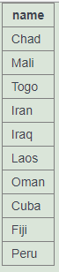

1. Question: The capital of **Luxembourg** is **Luxembourg**. Show all the countries where the capital is the same as the name of the country

**Find the country where the name is the capital city.**

1. Answer: SELECT name FROM world WHERE name = capital

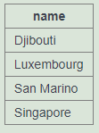

1. Question: The capital of **Mexico** is **Mexico City**. Show all the countries where the capital has the country together with the word "City".

**Find the country where the capital is the country plus "City".**

***The concat function:***

**The function concat is short for concatenate - you can use it to combine two or more strings.**

1. Answer:
2. Question: **Find the capital and the name where the capital includes the name of the country.**
3. Answer:
4. Question: **Find the capital and the name where the capital is an extension of name of the country.**

You *should* include **Mexico City** as it is longer than **Mexico**. You *should not* include **Luxembourg**as the capital is the same as the country.

1. Answer:
2. Question: For **Monaco-Ville** the name is **Monaco** and the extension is **-Ville**.

**Show the name and the extension where the capital is an extension of name of the country.**

You can use the SQL function [REPLACE](https://sqlzoo.net/wiki/REPLACE).

1. Answer:
2. SELECT from “World” 🡸 (name of table below)

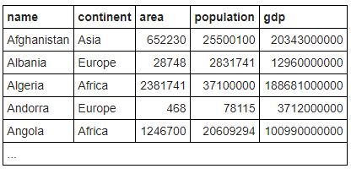

1. Question: SELECT name, continent, population FROM world
2. Answer: (prints the entire table, but only shows the attributes: name, continent, and population)
3. Question: Show the name for the countries that have a population of at least 200 million. 200 million is 200000000, there are eight zeros.
4. Answer: SELECT name FROM world WHERE population >= 200000000;

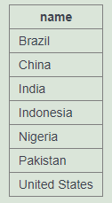

1. Question: Give the name and the **per capita GDP** for those countries with a population of at least 200 million.
2. Answer:

SELECT name, (gdp/population) FROM world

WHERE population >= 200000000;

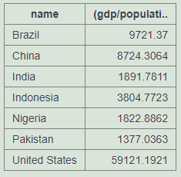

1. Question: Show the name and population in millions for the countries of the continent 'South America'. Divide the population by 1000000 to get population in millions.
2. Answer:

SELECT name, population/1000000 FROM world

WHERE continent = 'South America';

1. Question: …
2. SELECT from Nobel
3. Question: …
4. SELECT within SELECT
5. Question: **List each country name where the population is larger than that of 'Russia'.**
6. Answer (using nested SELECTs):

SELECT name FROM world

WHERE population >

(SELECT population FROM world

WHERE name='Russia');

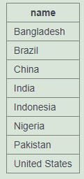

1. Question 2: **Show the countries in Europe with a per capita GDP greater than 'United Kingdom'.**
2. Answer:

SELECT name FROM world

WHERE (continent = 'Europe') AND ((gdp/population) >

(SELECT gdp/population FROM world

WHERE name = 'United Kingdom'));

1. Question: **List the name and continent of countries in the continents containing either Argentina or Australia. Order by name of the country.**
2. Answer:

SELECT name, continent FROM world

WHERE continent =

(SELECT continent FROM world

WHERE name = 'Argentina') OR

continent =

(SELECT continent FROM world

WHERE name = 'Australia')

ORDER BY name;

1. Question: **Which country has a population that is more than Canada but less than Poland? Show the name and the population.**
2. Answer:

SELECT name, population FROM world

WHERE population >

(SELECT population FROM world

WHERE name = 'Canada') AND

population <

(SELECT population FROM world

WHERE name = 'Poland');

1. SUM and COUNT
2. JOIN

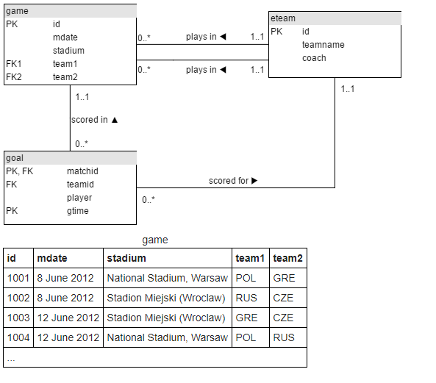

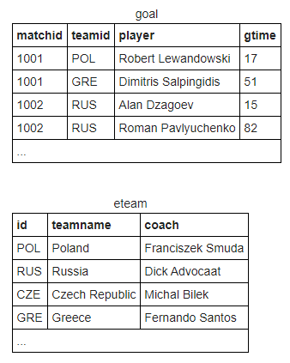

1. Question: The first example shows the goal scored by a player with the last name 'Bender'. The * says to list all the columns in the table - a shorter way of saying matchid, teamid, player, gtime

**Modify it to show the *matchid* and *player* name for all goals scored by Germany. To identify German players, check for: teamid = 'GER'**

1. Answer:

SELECT goal.matchid, goal.player

FROM goal INNER JOIN eteam

ON goal.teamid = eteam.id

WHERE teamid = 'GER';

1. Question: From the previous query you can see that Lars Bender's scored a goal in game 1012. Now we want to know what teams were playing in that match.

Notice in the that the column matchid in the goal table corresponds to the id column in the game table. We can look up information about game 1012 by finding that row in the **game** table.

**Show id, stadium, team1, team2 for just game 1012**

1. Answer:
2. Question:
3. Answer:
4. Question:
5. Answer:
6. More JOIN operations
7. Using Null
8. SQL Quiz

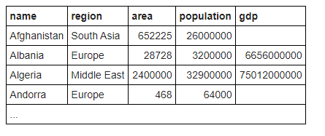

1. Question: Select the code that produces this table:

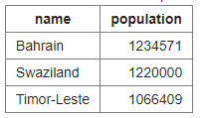

1. Answer:

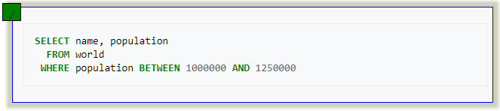

1. Question: Pick the result you would obtain from this code:

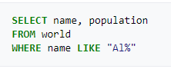

1. Answer:

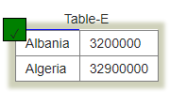

1. Question: Select the code which shows the countries that end in A or L
2. Answer:

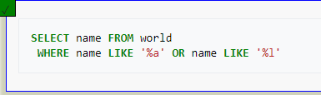

1. Question: Pick the result from the query

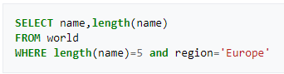

1. Answer:

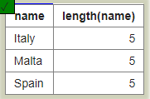

1. Question: Here are the first few rows of the world table

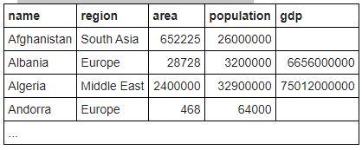

Pick the result you would obtain from this code:



1. Answer:



1. Question: Select the code that would show the countries with an area larger than 50000 and a population smaller than 10000000
2. Answer:

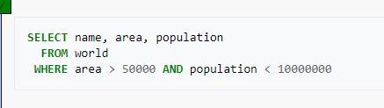

1. Question: Select the code that shows the population density of China, Australia, Nigeria and France
2. Answer:

